One on One Tools and Techniques
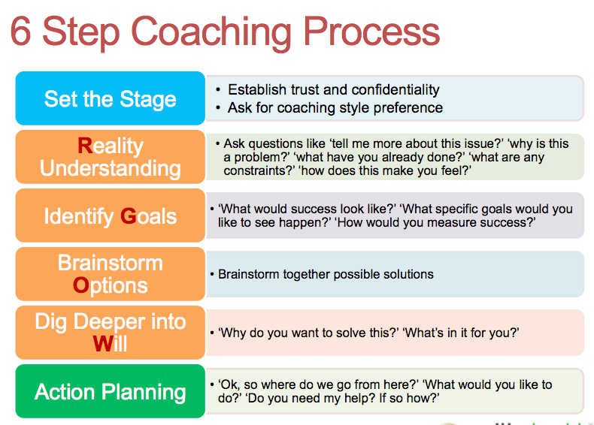

Addressing Unhealthy Behavior
1 - Explain clearly the unhealthy behavior and why it’s a problem:
2 – Provide an opening of a possible ‘reasonable’ root cause, give them the Benefit of the Doubt:
3 – Ask for their thoughts on solutions for addressing the behavior
4 - Move to commitment and action steps
5 - Thank you and follow up

Group Tools and Techniques

Common Ground
When to Use: | When there are two solutions presented that seem to be on opposite ends of the spectrum and neither one is viable. Your goal is to help the team find a common ground solution that sits in the middle and will need compromise by both parties.
Setup: | Split a flip chart into half with a vertical line. Label one side ‘Differences’ and the other side ‘Common Ground’
Instructions: | Say: ‘Team, I’m hearing that we have some differences on this issue but I also think we can find some common ground. Let me summarize the differences I’m hearing on this left side.’ .. ‘Did I get this right?’  Say: ‘Ok, now to effectively move forward, I want you to pretend you are a neutral third party looking at this situation objectively and from the outside. What common ground options do we see that may require some degree of compromise yet still satisfy our basic needs?’  Start writing these on the right side.  Say: ‘Ok, which one of these can we live with and support as a team?’

Evaluation Criteria Rating
When to Use: | When the team needs to choose between two or more viable options (tools, technologies, vendors, locations, build vs. buy) and it seems that there are multiple criteria that are weighing into our evaluation.
Setup: | Using a flip chart, draw three vertical lines and label the first column ‘Criteria’, and the rest of the columns <option a> <option b> ..etc.
Instructions: | Say: ‘Team, can we do a quick brainstorm to identify what are the key criteria we are using to evaluate these options? For example are we thinking cost, time are factors?’ begin listing them vertically.  Say: ‘Ok, before we discuss the options, can you tell me if all these criteria have equal weight? If not, how can we weigh them differently using a multiplier? Example, cost maybe X3 for us. ’  Say: ‘Now, for our first criteria, let’s discuss which option is stronger and has an advantage, give that option 1 point credit or 2 points if it has a significant advantage. If both are equal then no points assigned.’ Repeat for remaining criteria.  Say: ‘Lets total these up, remember to use the weight multiplier, which option has more advantage points? Does this help us make a decision? Are we missing anything?’

Evaluation Criteria Sample (For deciding between two candidates to join the team):
Evaluation Criteria | Candidate A | Candidate B
Team fit (x3) | 1
Technical skills (x2) |  | 2
Analytical skills (x2) | 2
Communication | 1
Organization |  | 1
Knowledge of Agile | - | -
Social interaction | 1
Totals: | 7 | 5
Based on these results, it seems that the team is leaning towards Candidate A
Team Brainstorming
When to Use: | When you feel like there are several questions, issues, concerns raised regarding a specific topic (Example ‘Resource allocation’) and you want your team to brainstorm a set of solutions then pick the ones they feel are most effective to implement and they are willing to support.  This helps gain buy-in and create sustainable solutions.
Setup: | Have lots of 4x4 Sticky Post-It notes and markers available on the tables. Setup 2 flip charts, each one divided into half across the center horizontally. Label the first: ‘Concerns/Issues’ , ‘Top Issues’ and the second ‘Solution Ideas’ , ‘Top Solutions/ Action Items’.
Instructions: | Say: ‘Team, it seems like we all have several issues/concerns on XYZ topic. Our goal is to get these on the table so we can identify some good viable solutions. Group together in small teams and begin to brainstorm this question: ‘What are the key issues, concerns you have around xyz topic?” write these issues on these post-it notes. One idea per post-it note. Don’t discuss them in detail please, just jot them down. You have 5 minutes’  Say: ‘Ok, each team come up and read your concerns and post them on this ‘Concerns/Issues’ flip chart, try to eliminate duplicates please or stick yours on top of the duplicate one.’ (you can have them do another 1 or 2 minutes if some folks have new ideas now that they’ve seen others.  Say: ‘Now, our goal is to identify which ones are the top ones we need to focus on. Should we pick our top X? Ok, each one of you will have X straw votes to use, you can use more than one straw per idea to give it a higher weight. Come up with your marker and use your straws to pick your top concerns.’  Now total the top X issues and announce the results or get consensus on handling any ties. Please the top ones on the flip chart portion titled ‘Top Issues’.  Repeat the process above for brainstorming the solutions. After picking your top solutions create an action plan for who needs to do what by when so these solutions can be implemented.

